Exercise 13
- Which Command displays the MSQL version?
SELECT VERSION();
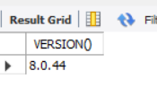
- Use the SELECT command to evaluate 4X4X4 and name the column Cube of 4.
SELECT 4 * 4 * 4 AS 'Cube of 4';
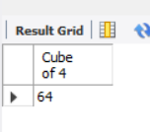
- Display your name with SELECT.
SELECT 'Jenny Mangubat' AS 'My Name';
SELECT 'Jenny Mangubat';
